**DATABASE DIAGRAMS**

Identifier Database Diagram

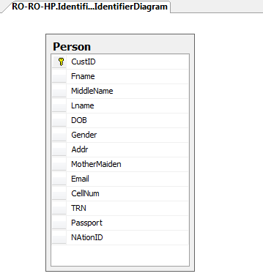

National ID Database Diagram

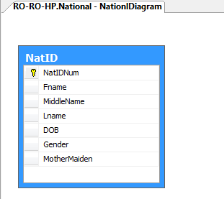

Passport Database Diagram

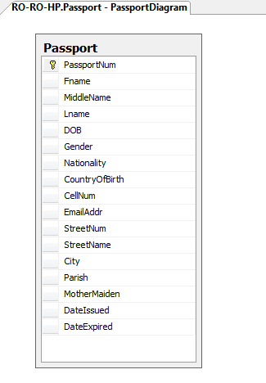

TRN Database Diagram

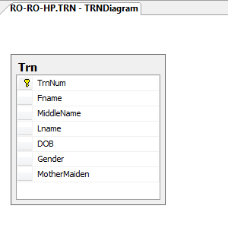

Application Diagram



IDENTIFIER DATABASE



TRN DB PASSPORT DB NATIONAL ID DB

  